5. ReactJS-HOL

My Academy team at Cognizant want to create a dashboard containing the details of ongoing and completed cohorts. A react application is created which displays the detail of the cohorts using react component. You are assigned the task of styling these react components.

Download and build the attached react application.

code:

# Create a new CSS Module in a file called “CohortDetails.module.css

.box {

width: 300px;

display: inline-block; margin: 10px;

padding: 10px 20px; border: 1px solid black; border-radius: 10px;

}

dt {

font-weight: 500;

}

CohortDetails.js

import React from "react";

import styles from "./CohortDetails.module.css";

function getStatusColor(status) {

return status === "Ongoing" ? "green" : "blue";

}

const CohortDetails = ({ cohorts }) => (

<div>

<h2>Cohorts Details</h2>

{cohorts.map((cohort) => (

<div key={cohort.name} className={styles.box}>

<h3 style={{ color: getStatusColor(cohort.status) }}>{cohort.name}</h3>

<dl>

<dt>Started On</dt>

<dd>{cohort.startedOn}</dd>

<dt>Current Status</dt>

<dd>{cohort.status}</dd>

<dt>Coach</dt>

<dd>{cohort.coach}</dd>

<dt>Trainer</dt>

<dd>{cohort.trainer}</dd>

</dl>

</div>

))}

</div>

);

export default CohortDetails;

App.js

import React from 'react';

import CohortDetails from './components/CohortDetails';

function App() { const cohorts = [

{

name: "INTADMDF10 - .NET FSD",

startedOn: "22-Feb-2022", status: "Scheduled", coach: "Aathma",

trainer: "Jojo Jose",

},

{

name: "ADM21JF014 - Java FSD",

startedOn: "10-Sep-2021", status: "Ongoing",

coach: "Apoorv", trainer: "Elisa Smith",

},

{

name: "CDBJF21025 - Java FSD",

startedOn: "24-Dec-2021", status: "Ongoing",

coach: "Aathma", trainer: "John Doe",

},

];

return (

<div className="App">

<CohortDetails cohorts={cohorts} />

</div>

);

}

export default App;

Output:

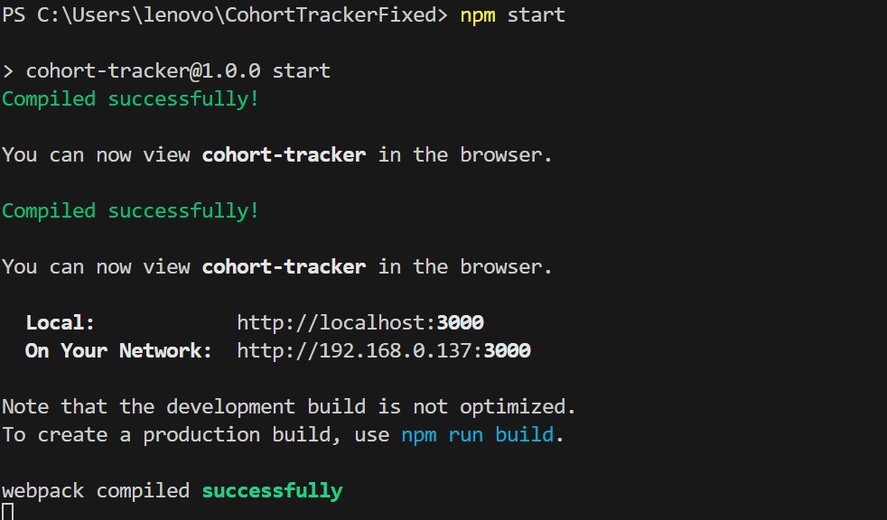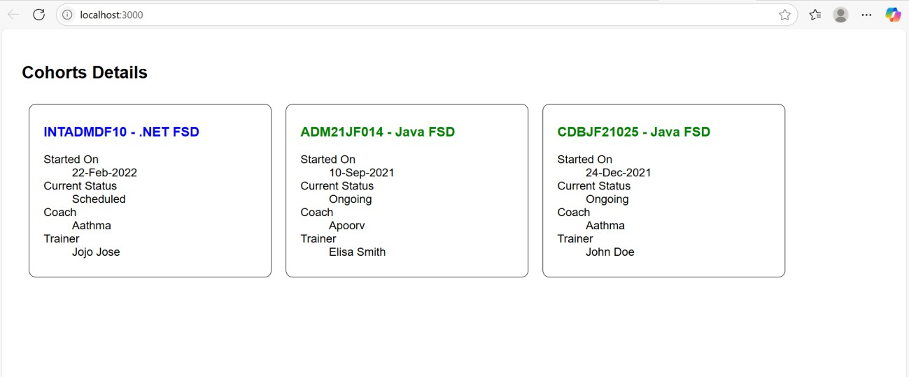

OUTPUT:

